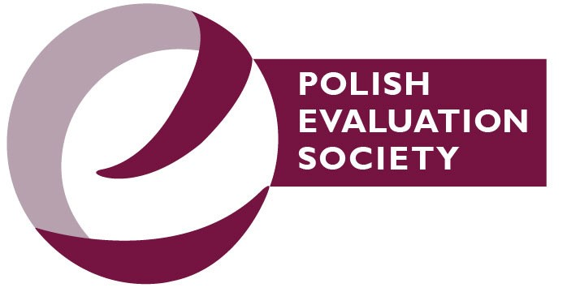
WE PROVIDE EVALUATION STANDARDS IN POLAND
Short presentation of the Polish Evaluation Society(P
TE)
5
th Western BalkanEvaluation Network conference
Ljubljana, 29-30.09.2023
by
Paweł Penszko
–a memberof the PolishEvaluation Society
PTE’s milestones
- 2000 – PTE established
- 2004 – cooperation with the Ministry of Development Funds (UE) and Regional Policy
- 2008 – Evaluation Standards
- 2010 – training program „Evaluation Forge” (6 day long), then blended-learning version of this course
- 2015 – 1st Evaluation Congress
- 2020 – Evaluation Qualifications Framework
- 2022 – Polish Evaluation Review
- 2022 – yearly budget of about EUR 27,500
(60% of it – one grant for the „Evaluation Think Tank” project)
- 2023 - 95 members

The PTE’s Strategy 2021-2027
THREE AREAS OF OUR ACTIVITIES:
1. Developing Evaluation
- Professionalization (standards, certification, advocacy)
- Research, innovative initiatives
2. Spreading Evaluation
- Dissemination of knowledge and skills (publishing, education)
- Cooperation with various stakeholders (at the national and international levels)
3. PTE’s Capacity Building
- Resource management
- Public relations (membership, communication)

Area: Developing Evaluation
- Developing Guiding Principles (to complement Evaluation Standards)
- Participation in the Cohesion Policy Evaluation
Steering Group
- Applied to be a certification body for Evaluator’s Qualification – rejected by the Ministry

Area: Spreading Evaluation
- 3rd International Evaluation Congress 2021‚ https://www.youtube.com/@pte7509/playlists
- Polish Evaluation Review, expert reports, publications ▪ Organizing open and dedicated training
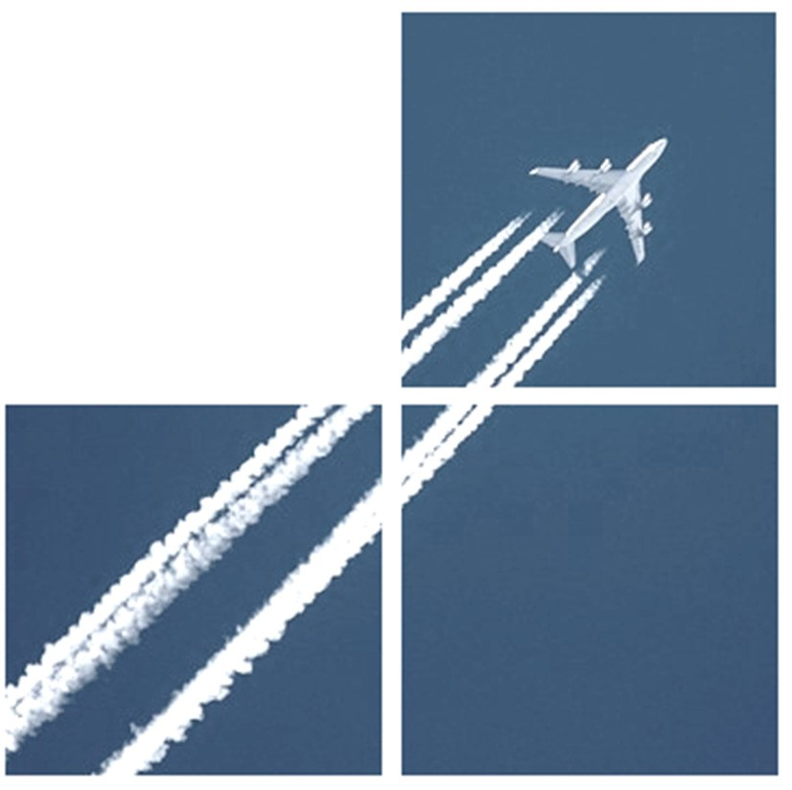
- Mentoring Programme MENTOR4EVAL (9 mentors, 12 mentees)
- Monthly webinars
- Seminars and meetings with municipalities
- Cooperation with universities (consulting curricula, joint study on the evaluation market)
International Cooperation
Member of
- Network of Evaluation Societies in Europe (NESE)
- International Organization for Cooperation in Evaluation (IOCE)
- Inter-Regional Initiative for Professionalization of Evaluation (IRIPE)
Cooperation with other VOPEs
- Ukrainian Evaluation Society
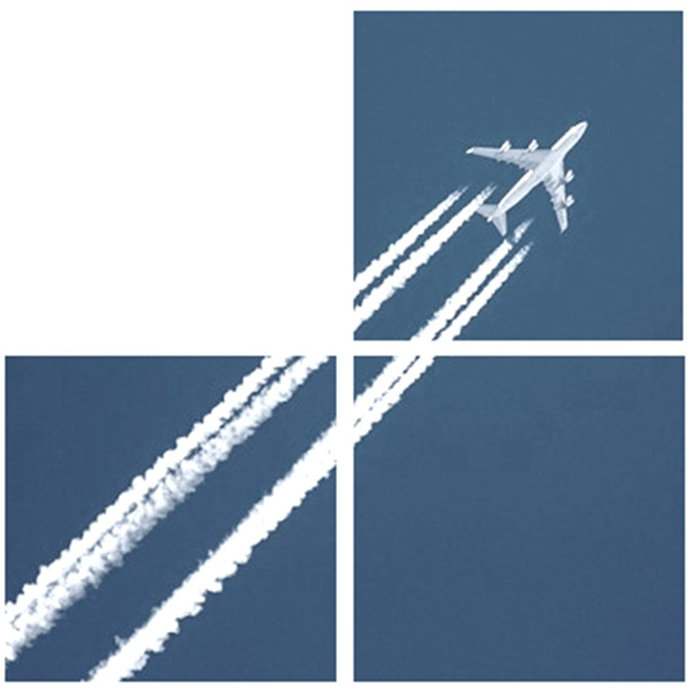
International projects (together with WBEN members)
- Assessment of the Current State of Democracy,
Human Rights and Governance (DRG)
Evaluation in Europe
- Strengthening VOPEs’ capacities in Europe: A practical approach for streamlining the evaluation of Key Horizontal Principles

Area: PTE’s Capacity Building
- Developing PTE’s strategy, yearly operational plans
- Working on a new PTE’s statute
- Archivization
- Communication to the members – newsletter, blog, social media
- Translation of the website to English: pte.org.pl/en/

Thank you for your attention!
Hvala za pozornost! Hvala na pažnji!
Ви благодарам за вниманието!
https://pte.org.pl/ pte@pte.org.pl
